Name: Addison Kelly
Student ID: 1237585871
Date: 05/01/2026

Instructions: Congratulations, you made it to the end of the course! Use the following to have a written discussion about your experience in the course and the final project. After you answer the questions below, insert a screenshot of each of the pages you have completed so far (remember, you should have at least 4 and the CSS file). Do NOT screenshot the html code because we can’t run the code. Save the file to yourasurite – Project – Assignment 5.docx file and yourasurite – Project – Assignment 5.pdf file.

Before submitting this document and all your project files, make sure you meet all of these requirements listed in the CIS300 Project Instructions.pdf file.

Discussion Questions
- Now that you are finished with your project, your original concept of your project might have changed a lot. Discuss in detail the differences between your initial project design and your final product. Why did you make these changes (if you had any)? (5 points)
The biggest changes are that I changed the color scheme, the original idea had multiple bright colors and gradients and was simply too busy and cluttered looking. This change brought a cleaner and less distracting visual layout with a more professional feeling to it.
- Describe in detail why you chose the design layout you did. Are you happy with the outcome? Did you run into any issues with your design while developing your site? What did you do to overcome those issues? Would you do anything differently the next time you designed a website? (5 points)
I chose the layout to have a simple modern looking design that draws attention to the main point of the page. I wanted the title to be above and centered, with a welcome message centered on the page. The left side teaches you about photography, the right gives you a chance to give feedback. The navigation bare allows you to browse the pages, and this needed to be consistent and centered one each page. With another site I might try an even simpler page with a white background and pictures that pop on the screen more.
I also plan to continue to develop this website and add more of my pictures to the gallery. It is so fun to design my own portfolio!

- You likely encountered challenges while working on your final project. In detail, describe the challenges you encountered and what you did to overcome them. (5 points)
I had challenges with sizing and styling, but I used ChatGPT to help give me suggestions and ideas that I played around with to achieve the look I wanted. For example, when there was text that was not staying centered on the page, I was trying to use text-align: center to fix it. ChatGPT helped me see that what I needed to use was Margin: 0 auto for centering on the web page.
I also had a challenge of wanting to record the data submitted in the form but keep the form as the one I coded on the webpage. This took a little bit of learning about formspree.com and how I could use JavaScript to enhance the functioning of the form. However, sadly the rubric states that I must use # as the action on the form so it won’t be the working version I created in my deliverable.
- Describe several concepts that you learned during this course that you found interesting and useful. Where there any concepts that you wish more time was spent on? Is there anything you would have like to incorporate into your final project that wasn’t covered during this course? (5 points)
Some very interesting and useful concepts include how to create the basics of an internet website, edit the layout using html and style it with CSS. CSS is an incredible resource I had not used before. Also incredibly helpful was learning how to use AI to assist me in the process of building a website. There were so many things I learned I cannot even cover it here!

- List your project website's GitHub Repo URL and Published URL. (1.5 points/URL)
GitHub Repo URL: akellyhappyfree/akellyhappyfree.github.io
Published URL: akellyhappyfree.github.io
- Insert your website’s Google Analytics Realtime Overview Screenshot below (10 points)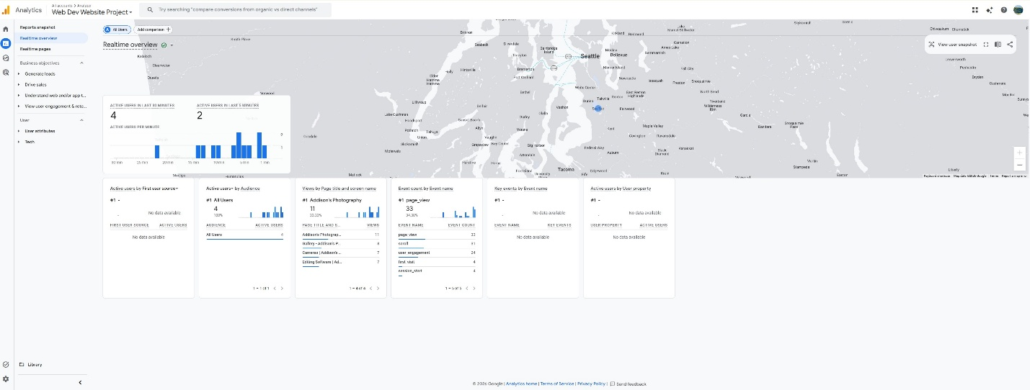

- While trying to be as objective and unbiased as possible, please go through and critique your own site using the attached rubric. In the student critique column, indicate which score you should receive for each category (outstanding, average, or needs improvement) and write a short (1 or two sentence max) justification of that score. (5 points)
Student Critique
 | Outstanding | Average | Needs Improvement | Student Critique
EXAMPLE | You did everything! | You did a few things. | You did nothing… | Outstanding – I believe I did everything correctly because of x, y, and z.
Visual Appeal | Use of color, contrast, text, graphics is appealing to target audience | Appealing to target audience in all but one area. | Not appealing to target audience in more than one area | Outstanding – I think the simplicity and professional look will be appealing to the target audience: photographers and audiences.
Navigation | Easy to use, consistent | Inconsistent or difficult to use | Missing | Outstanding – Very simple and easy to use with no confusion
Page Titles/ Logo Area | Descriptive and include the site/company name | -- | Missing or does not include the site/company name | Outstanding-Every page is titled and has multiple descriptors.
Table | Present and correct syntax | -- | Missing or incorrect syntax | Outstanding – The table is orderly and correct
Video | Present and correct syntax | -- | Missing or incorrect syntax | Outstanding – Video is present with correct syntax
E-mail Link | Present and correct syntax | -- | Missing or incorrect syntax | Outstanding -
Outside Link | Present and correct syntax | -- | Missing or incorrect syntax | Outstanding -
Meta tag | Correct syntax (description meta tags), excellent selection of keywords and meaningful description | Correct syntax (description meta tags), adequate selection of keywords and description | Missing or incorrect syntax | Outstanding or Average: Depending on your view, but I think my descriptions are clear and meaningful.
Form Coding | Contains 4 or more form fields, correct syntax, and meaningful form element names | Does not contain the required 4 form fields, incorrect syntax, or names of fields don’t make sense. | Missing | Outstanding = Form is perfectly coded
Form Processing | Form uses # as the action. | -- | Form not configured correctly. | Outstanding – I configured correctly

Web page browser view screenshot of Home Page
This page includes video, form, email, external links.
Home Page
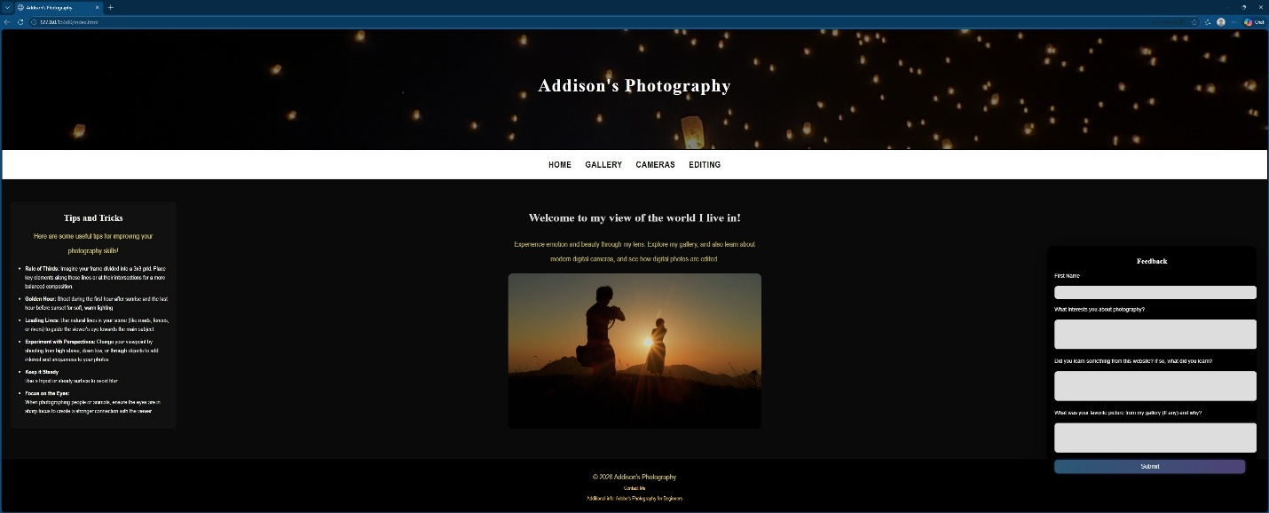

Web page browser view screenshot of Page #1
This page includes pictures
Gallery
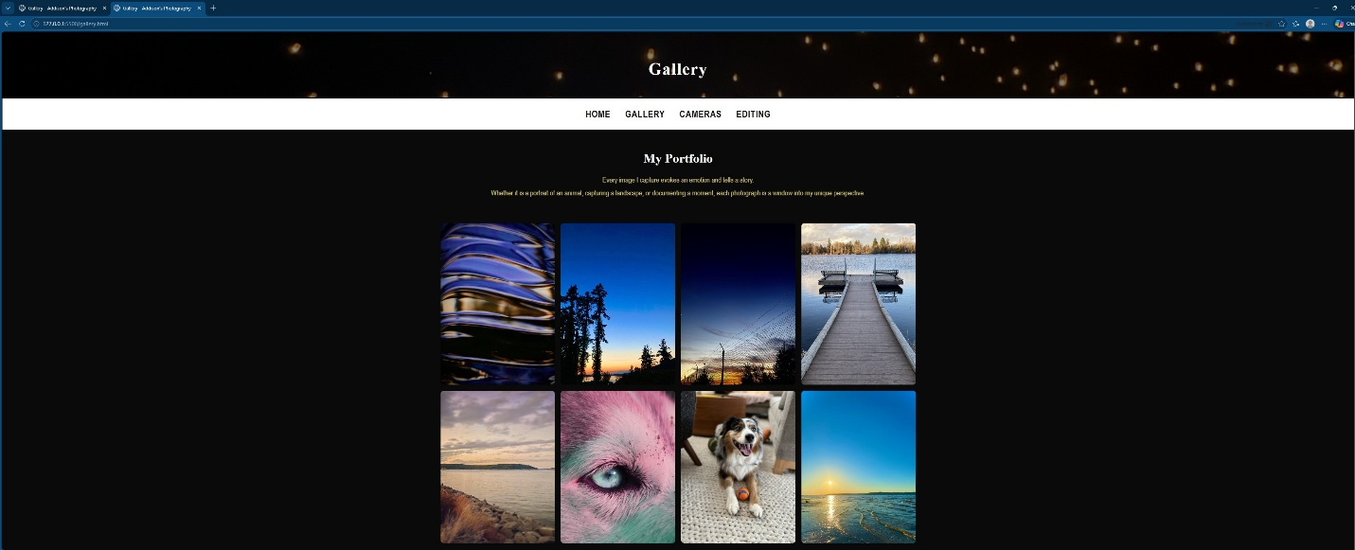

Web page browser view screenshot of Page #2
This page includes a table
Cameras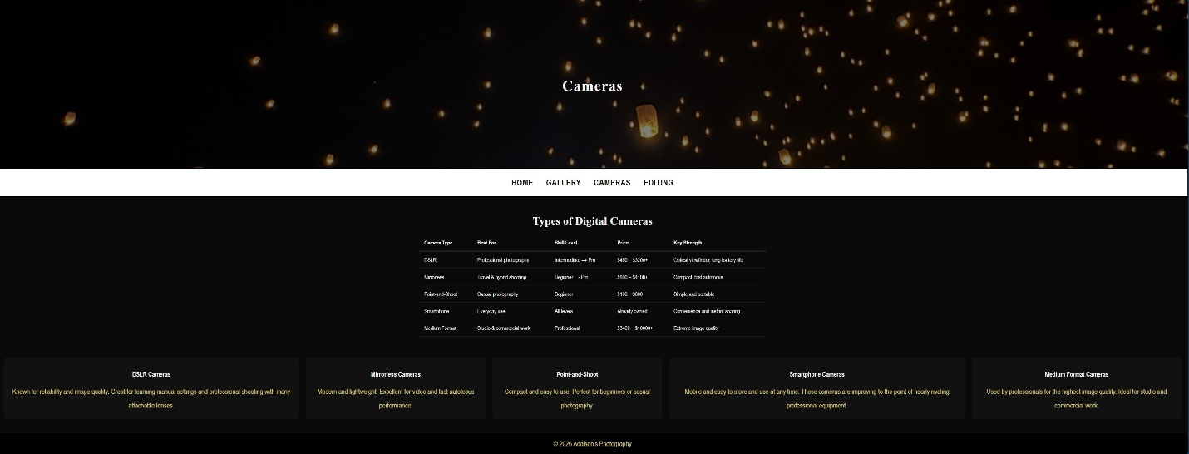

Web page browser view screenshot of Page #3
This page includes a table
Editing
